Public Transportation in Minneapolis, Minnesota

A Case Study

Prepared by

Carly Haithcock

for



September 22, 2015

Background 3

Transportation Options in Minneapolis 4

Evaluation 6

Applications for Memphis 7

References 9

Appendix A 10

Though Minneapolis and St. Paul, Minnesota are referred to as the Twin Cities and are both served by the same transit agency, this case study primarily focuses on public transportation in Minneapolis since Minneapolis has the majority of transit service and has a larger population and economy.

# Background

**What**

Minneapolis’ approach to transportation has been piecemeal. There was no major plan or initiative that resulted in the system that exists today. Instead it has been a result of progressive decision-making regarding urban issues and plans being developed to support these decisions. Specifically, two strategies that have been instrumental in the success of Minneapolis’ transit system: fiscal equalization and public participation.

**How**

In the 1950s, the trend of cities offering financial incentives to companies in exchange for jobs began to take hold. Minnesota followed this trend for years until 1961. Widening inequality caused by depleted municipal budgets and deteriorating social services led the Minneapolis state legislature to enact a law (Atlantic, 2015) now referred to as“fiscal equalization”. It requires municipalities to contribute almost half of the growth in their commercial tax revenues to a regional pool, from which the money is distributed to tax-poor areas. Again, decentralized decision-making that benefits the whole and not just a part proves to be most successful and equitable.

Minneapolis also emphasizes public engagement. The Public Engagement Plan draft version encourages a shift from participation to engagement (PEP Draft, 2015) in the planning process. This 18-page plan details the shift to more meaningful participation, provides standards for engagement, and details examples of appropriate levels of engagement based on scale of the plan, etc.

The “Minnesota Nice” stereotype seems to also have a role in Minneapolis culture. Source--Minneapolis in the second most agreeable and fifth most extroverted state (Renfrow et. al. 2008) in the country.

**Where**

Minneapolis, Minnesota is the located in the Midwest region of the United States of America. It lies at the junction of the Minnesota and Mississippi Rivers and serves as the region's major commercial center. Selected demographic characteristics are shown below in Table 2.

Table 2. 2014 Selected Demographics.

|  |  |  |
| --- | --- | --- |
| Total Population | | 407,181 |
|  |  |  |
| White alone | | 65% |
| Black |  | 20% |
| American Indian | | 1% |
| Asian |  | 6% |
| Native Hawaiian | | 0% |
| Some other race alone | | 4% |
| Two or more races | | 4% |

|  |  |  |
| --- | --- | --- |
| % living in poverty | | 22.5% |
|  |  |  |
| Density |  | 6,972 p/sq.mi. |

*Source: 2014 American Community Survey, 1-year estimates.*

**Who**

Minneapolis has a weak-mayor system consisting of the mayor and elected representatives of 13 wards. The Metropolitan Council is the regional policy-making body, planning agency, and provider of essential services (Metro Council, 2015) for the Twin Cities metropolitan region. The Metropolitan Council is in charge of planning, wastewater and water, and transportation for St. Paul, Minneapolis, and their suburbs. This regional planning approach has led to a more holistic planning of transportation in the region and eliminated partisan politics in some way, especially as it pertains to transportation.

**When**

Minneapolis’ transportation investments have been relatively recent. Light rail service began in December 2004 and the bike share system launched in 2010. The first public participation plan was released for comments in 2007.

# Transportation Options in Minneapolis

Minneapolis’ public transportation system consists of buses, light rail, commuter rail, and a bike share system. Metro Transit operates 123 bus routes made up of local, express, and high-frequency routes. Minneapolis has one operating bus rapid transit (BRT) line (Red Line) and planning is underway for METRO Orange Line and Gold Line. In addition to the local BRT routes, three arterial bus rapid transit lines slated to open in the coming years. Refer to Appendix A Figures 1 and 2 for a system map of the high frequency routes and entire bus system.

The Northstar Line is a commuter rail line providing service between Minneapolis and Big Lake, Minnesota. Service began on November 16, 2009 and extends 40 miles north of Minneapolis. The corridor has an additional 42 miles available for service but this extension has run into funding and political issues. See Figure 3 in Appendix A for the Northstar alignment and station locations.

Like many American cities, the Minneapolis–St. Paul area once had an extensive network of streetcars that were removed in 1950s as a result of the prioritization of the automobile. Congestion steadily increased and advocates for rail transit voiced their support for the reconstruction of a light rail system. After years of political wrangling, construction began in 2001. A 2003 report by the Texas Transportation Institute indicated that the area was the 17th most congested area in the country, with the second fastest congestion growth. (2003, Texas Transportation). There are currently two METRO light rail lines, the Blue and Green lines. Refer to Appendix A Figure 4 for a system map of the METRO Transitways (the lines designated by color).

NiceRide MN is the Twin Cities’ bike share system. It consists of 170 docks and 1,550 bikes. Despite its harsh climate, Minneapolis’ mode shares for walking and biking are increasing. Table 1 below shows the mode shares in 2010, 2012 and 2014.

*Table 1. Transportation Mode Share by Percent of Total Commuters.*



*Source: 2014 American Community Survey, 1-year estimates.*

# Evaluation

The quality of this public transportation system can also be evaluated based on how well each it addresses and enhances public health, social justice, economic development, and the environment.

Public Health

The Guaranteed Ride Home program is gaining popularity in many cities. The idea is that some people are discouraged from using transit because their schedule may change unexpectedly. Minneapolis’ Guaranteed Ride Home provides up to four reimbursements a year (or $100, whichever is first) for an emergency taxi, car-share, on-demand ride-share, rental car or transit trip. In addition to encouraging transit use, it also provides a free alternative to impaired driving. NiceRIDE MN’s Neighborhood Program (Stucker, 2014) provides a bicycle for the duration of the riding season to residents of typically underserved neighborhoods. Throughout the program, social rides and cycling skills classes are held to encourage a healthy lifestyle. Free maintenance is available at two bike co-ops.

Social Justice

Social justice is often the most difficult part of transportation planning. A part of the comprehensive plan (Thrive MSP), the *2040 Transportation Policy Plan* devotes an entire chapter to equity and environmental justice. METRO’s governance includes a Transit Advisory Board.  This group is formally recognized collection of public officials and private citizens who make recommendations, participates in drafting the Transportation Policy Plan, and reviews, and adopts the region’s three‐year Transportation Improvement Program. Its 33 members include 10 municipal elected officials; seven county commissioners; four state and regional agency representatives; eight citizen representatives; and four transportation mode representatives. They recently adopted equity considerations into funding formula. The Transportation Accessibility Advisory Committee composed of transit riders who have disabilities and advocates for the disability community, advise the Metropolitan Council on transportation services for people with disabilities. Some services for people with disabilities include Transit Link, Metro Mobility, and Metro Vanpool.

Metro Transit offers 50% subsidized fares to homeless and job-seeking individuals. During the planning phase of the Green Light Rail Line, the Council fought for the addition of three extra stops along (CNN Money, n.d.) the proposed alignment. These three stops were in black and immigrant neighborhoods that were bounded by interstates and effectively cut off from the rest of the city. The federal government opposed these additions based on cost and time but the stops were ultimately constructed.

Economic Development

The light rail lines have spurred $2.5 billion (Metro Council, 2015) of investment. This money has not only been invested in the wealthier neighborhoods. Those three additional stops on the green line have resulted in development by existing residents along alignment. There are seven new affordable housing projects under construction in those neighborhoods as well. This not only allows for more quality housing options but also allows people to move to a neighborhood with better job access via transit. A community fund was established to help existing businesses during construction. This assistance came in the form of non-repayable loans to businesses impacted by construction meant to minimize their losses.

Environment

Minneapolis, the city by Nature, is known as the one of the cleanest cities in America. METRO allows the use of highway shoulders to serve as bus route alternatives during heavy congestion. Currently there are 300 miles of bus-only shoulders on highways.  The Union Station Transit Center is LEED Gold certified.

# Applications for Memphis

The Twin cities regional government has made collaboration and more holistic thinking possible. Transit and planning is not just for a select group in one city, it serves to benefit the whole region. Memphis and Shelby County consolidating (like Nashville and Chattanooga have done to some degree) could lead to better services and more efficient use of public money. Memphis adopted a meaningful participation plan and requiring equity considerations would make vast improvements in all services.

# References

Hargreaves, S and Aratari, D. (n.d.). *How the Twin Cities got transit right*. Retrieved from

<http://money.cnn.com/interactive/technology/minneapolis-light-rail/>

Stucker, P. (2014, 21 July) *Orange: A New Outreach Effort from Nice Ride Minnesota.* Retrieved from https://www.niceridemn.org/news/2014/07/21/134/orange_a_new_outreach_effort_from_nice_ride_minnesota/

Metro Council. (2015, 4 May). *Metro green line helps attract at least $2.5 billion in development*. Retrieved from http://metrocouncil.org/transportation/projects/current-projects/central-corridor/news-display-page/metro-green-line-helps-attract-at-least-$2-5-billi.aspx

Metro Council. (2014, 23 July). *Public Engagement Plan Draft*. Retrieved from http://www.metrocouncil.org/Council-Meetings/Committees/Metropolitan-Council/2014/7-23-14/PEP-DraftforOutreach.aspx

Metro Council. (n.d.). *Transportation Policy Plan 2040*. Retrieved from

http://www.metrocouncil.org/Transportation/Planning-2/Key-Transportation-Planning-Documents/Transportation-Policy-Plan-(1)/The-Adopted-2040-TPP-(1).aspx

Metro Council. (n.d.). *Thrive MSP 2040*. Retrieved from

http://www.metrocouncil.org/Planning/Projects/Thrive-2040/Thrive-MSP-2040-Plan.aspx

Rentfrow, P.; Gosling, S.; Potter, J. (2008, September). *A Theory of the Emergence, Persistence, and Expression of Geographic Variation in Psychological Characteristic*. Perspectives on Psychological Science 3 (5): 339–369.

Thompson, D. (2015, March). *The Miracle of Minneapolis*. Retrieved from http://www.theatlantic.com/magazine/archive/2015/03/the-miracle-of-minneapolis/384975/

# Appendix A

Figure 1. High-Frequency Service Routes.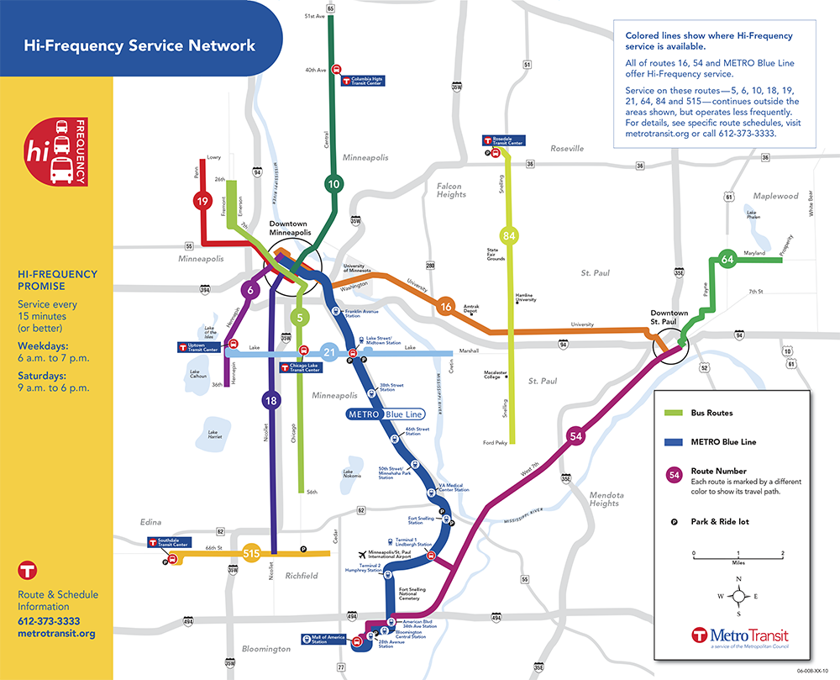

Figure 2. Metro Transit Bus System Map.

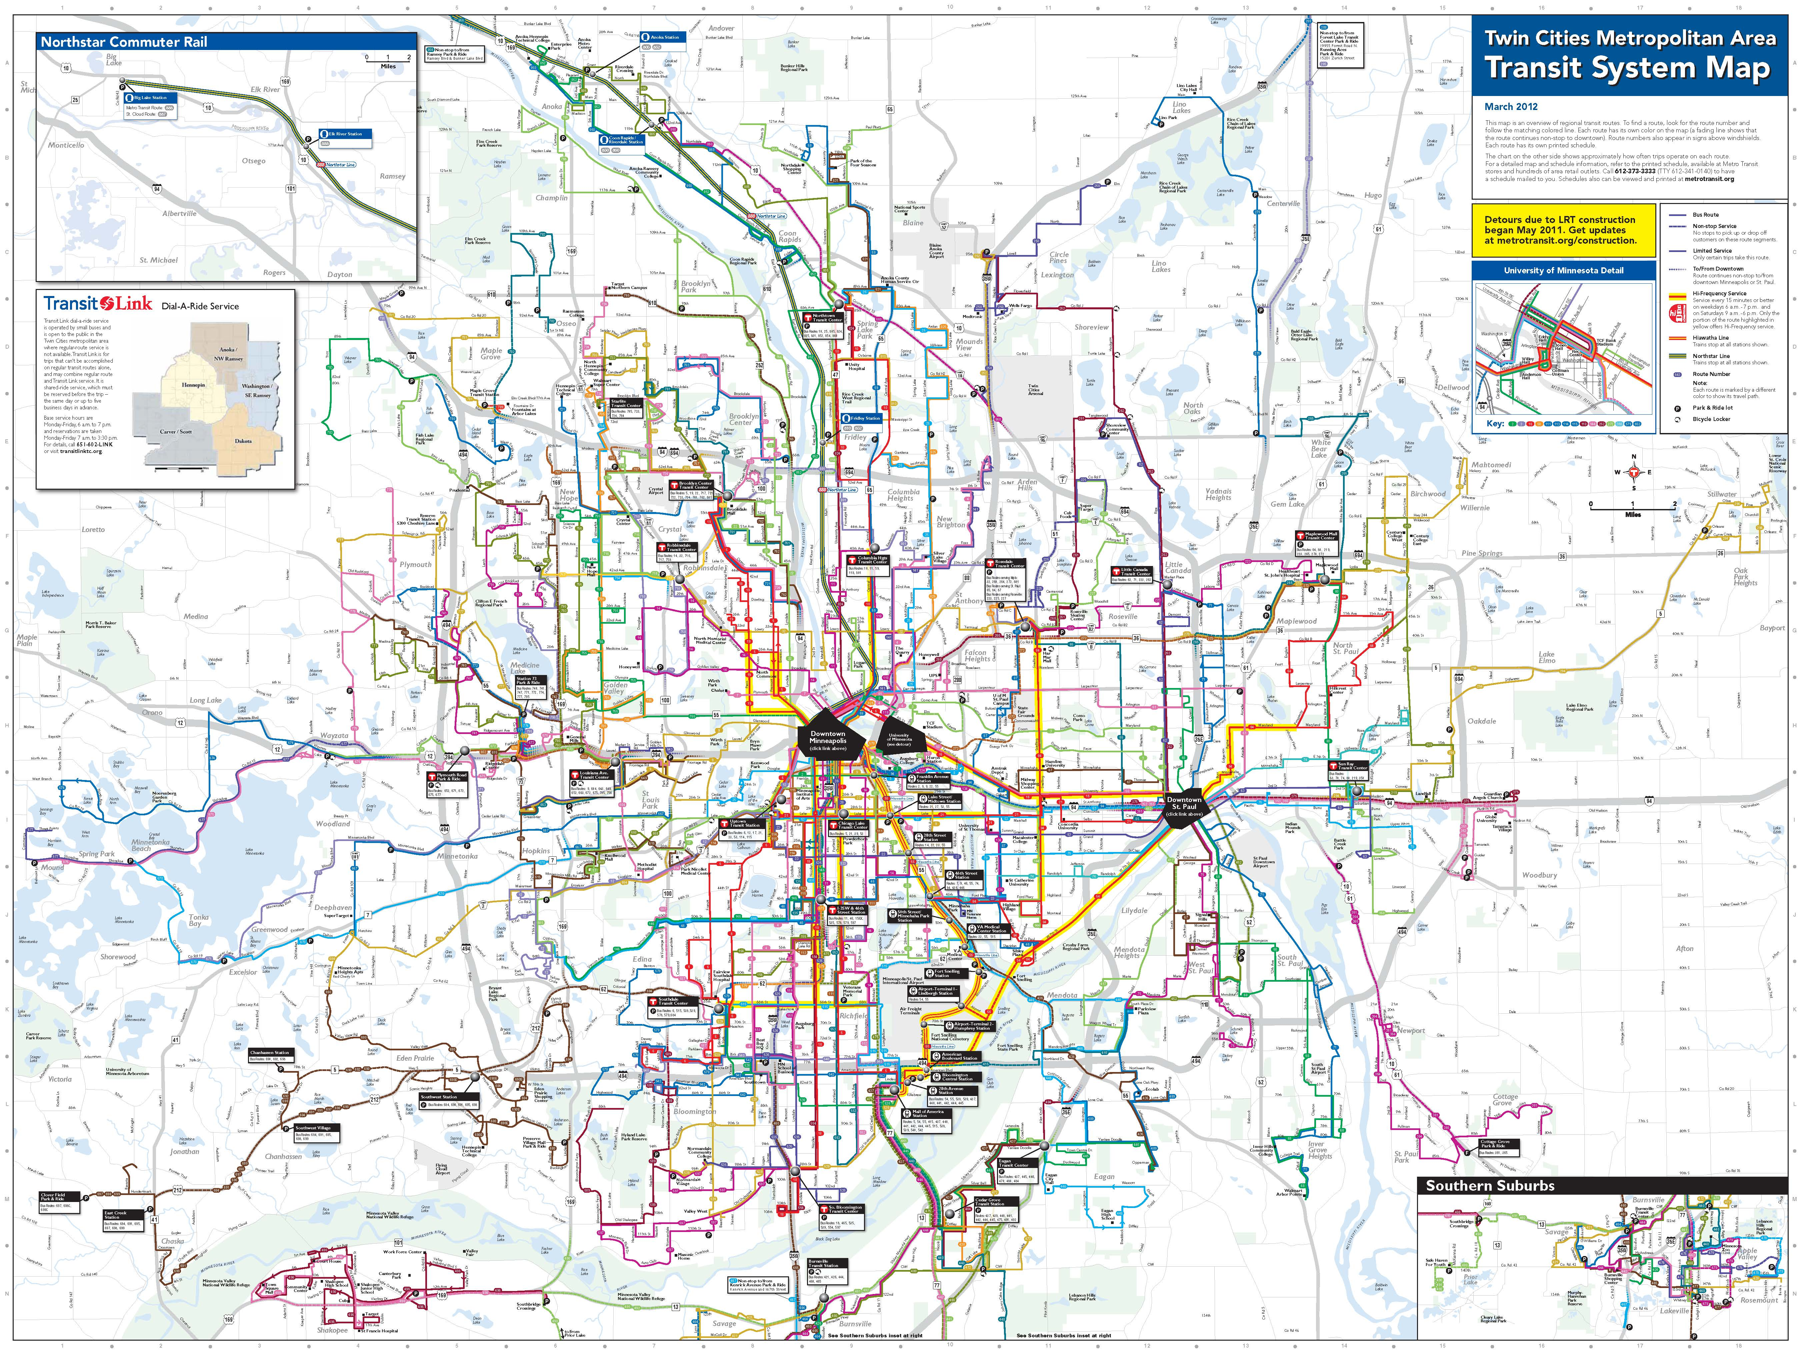

Figure 3. Northstar Commuter Rail Alignment and Stations.

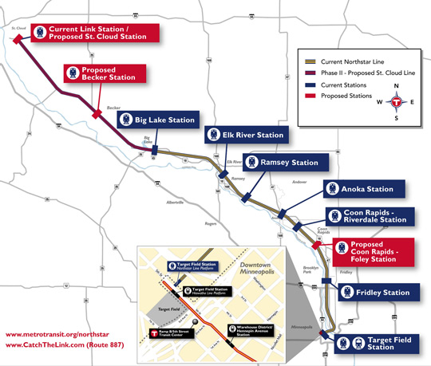

Figure 4. Metro Transitways System Map.